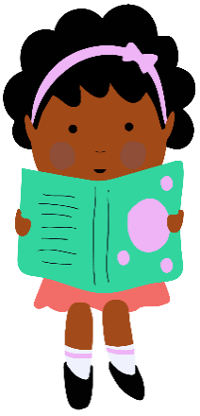

Giving children a wide variety of exciting and engaging new books to choose from is vital to their development as a reader and forms a key part of our Young Readers Programme. Here, we’ve put together a list of books for ages 7-8 that is sure to appeal to a broad range of interests!
Recommended books for Year 3

Click here to find all these titles on Browns Books
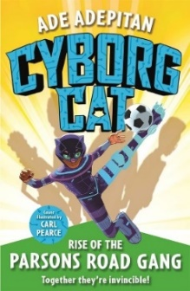 | Cyborg Cat: Rise of the Parsons Road Gang by Ade Adepitan  When Ade moves to London from Nigeria, he knows things will be different, but nothing can prepare him for the ups and downs of his Parson's Road adventures. Fitting in is hard, especially as he looks different to everyone else.  Interest age: 7-11  Reading age: 8+
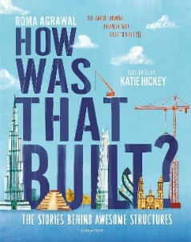 | How Was That Built? by Roma Agrawal  Join Roma Agrawal, award-winning structural engineer, for an exciting, behind-the-scenes look at some of the world's most amazing landmarks. Get ready to see the built world around you, like never before!  Reading age: 8+  Interest age: 8-12
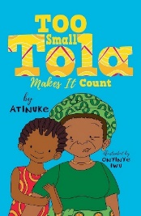 | Too Small Tola Makes It Count by Atinuke  Tola may be small, but she's very determined! Lockdown is over and Too Small Tola has returned to the crowded family flat in Lagos, Nigeria.  Interest age: 6-8  Reading age: 6+
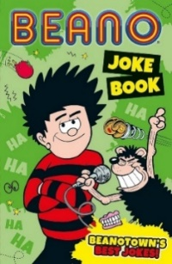 | Beano Joke Book by Beano Studios  It’s comedy night in Beanotown and Bash Street’s finest comedians have come together to compete for glory. Everyone has brought their funniest, most epic jokes. Who will you decide is the best joker?  Interest age: 6-11  Reading age: 7+
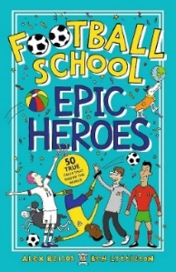 | Football School: Epic Heroes by Alex Bellos  Discover the greatest football moments of all time, in this collection of 50 exciting stories. Bringing together the best names in the game with weird, wonderful and hilarious occurrences, a must-read for any football fan.  Interest age: 6-11  Reading age: 7+

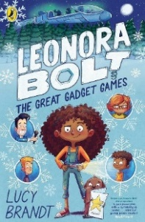 | Leonora Bolt and The Great Gadget Games by Lucy Brandt  Leonora gets an invite to the Great Gadget Games, but not all is as it seems…this is an epic STEM-themed adventure about believing in your brainpower - and yourself.  Interest age: 6-11  Reading age: 7+
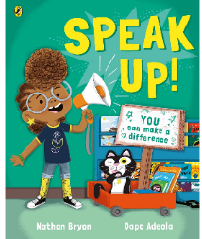 | Speak Up! by Nathan Bryon  Join the brilliantly passionate and instantly loveable Rocket, as she organises a peaceful protest to save her local library!  Interest age: 6-8  Reading age: 7+
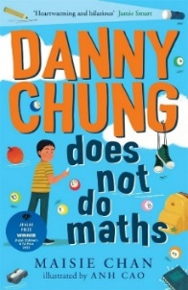 | Danny Chung Does Not Do Maths by Maisie Chan  Eleven-year-old Danny Chung loves drawing more than anything - certainly more than maths - which, according to his dad and everyone else, is what he is 'supposed' to be good at.  Interest age: 8-12  Reading age: 8+
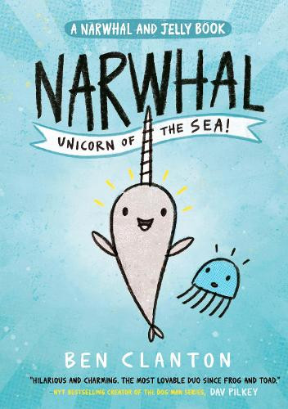 | Narwhal: Unicorn of the Sea! by Ben Clanton  Narwhal, a happy-go-lucky narwhal and Jelly, a no-nonsense jellyfish, might not have a lot in common, but they do love waffles, parties and adventures. Join Narwhal and Jelly as they discover the whole, wide ocean together.  Interest age: 6-8  Reading age: 6+
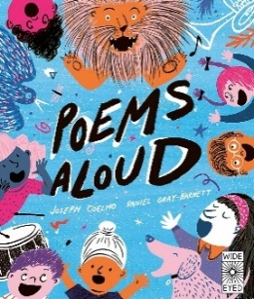 | Poems Aloud by Joseph Coelho  In this wittily illustrated anthology of poems, designed to be read aloud, twenty poems arm children with techniques for lifting poetry off the page and performing with confidence.  Interest age: 6-11  Reading age: 7+

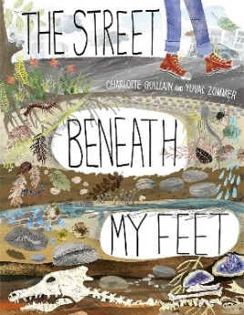 | The Street Beneath My Feet by Charlotte Guillian  When you’re out walking around, whether on the city streets or a country trail, there’s always so much to see and hear. But do you ever stop and look down? Have you ever wondered what’s going on deep in the ground, under your feet?  Interest age: 6-9  Reading age: 7+
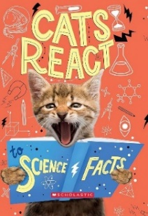 | Cats React to Science Facts by Izzi Howell  Share in the wonderment of science with crazy cats and measure your amazement, awe and disgust alongside their furry feline faces! Cats React to Science Facts is an engaging and fun way to understand science.  Interest age: 6-11  Reading age: 7+
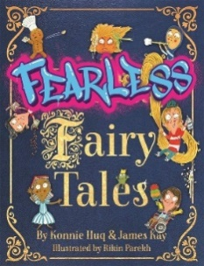 | Fearless Fairy Tales by Konnie Huq and James Hay  From fake news to female footballers; environmental pollution to equal pay, nothing is off limits in this anthology of laugh-out-loud fairy tales, with thoroughly modern morals.  Interest age: 6-11  Reading age: 7+
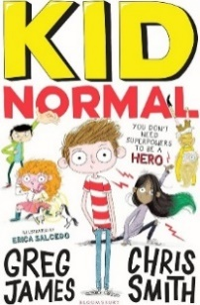 | Kid Normal Series by Greg James and Chris Smith  Murph Cooper has a problem. His new school is top secret and super weird. His classmates can fly, control the weather or conjure tiny horses from thin air. And what's Murph's extraordinary skill? Um, oh yeah, he hasn't got one.  Interest age: 8-11  Reading age: 8+
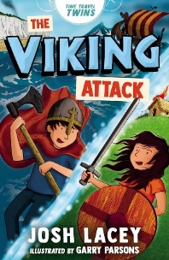 | The Viking Attack by Josh Lacey  Twins, Scarlett and Tom, are studying the Vikings and Anglo-Saxons at school and they have a homework project to do. When Tom's struggling for inspiration, Grandad comes to the rescue with his time machine.  Reading age: 7+  Interest age: 6-8
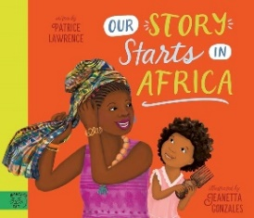 | Our Story Starts in Africa by Patrice Lawrence  When Paloma goes to visit her family in Trinidad, Tante Janet has a story to tell her: An ancient story of treasures and tales that span thousands of years...a story that Paloma shares in, because her story starts in Africa, too.  Reading age: 6+  Interest age: 5-8
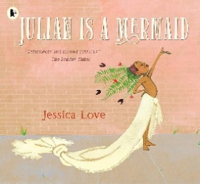
Julian is a Mermaid by Jessica Love
While riding the subway with his Nana, Julian notices three women spectacularly dressed up. When Julian gets home, all he can think about is dressing up like those ladies and making his own fabulous mermaid costume.
Interest age: 6+
Reading age: 4+
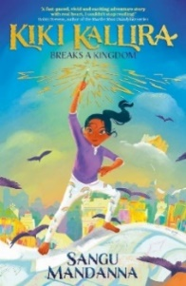 | Kiki Kallira Breaks a Kingdom by Sangu Mandanna  Kiki Kallira is more of a worrier than a warrior - but today she will learn to be a hero. The mythical beasts she loves to draw have come to life and she is the only one who can defeat them.  Interest age: 8-12  Reading age: 8+
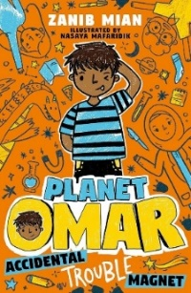 | Planet Omar by Zanib Mian  Welcome to the imaginative brain of Omar! Omar and his family have just moved, and he is NOT excited about starting at a new school. Luckily, Omar's imagination and goofy family help him get through life's ups and downs.  Interest age: 6-11  Reading age: 6+
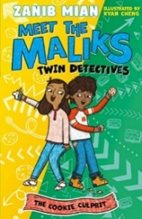 | Meet the Maliks, Twin Detectives by Zanib Mian  Meet Maysa and Musa Malik. They might be twins but they are total opposites. And together they make an unstoppable team, especially when trying to solve a mystery! Perfect for fans of Planet Omar and Tom Gates.  Interest age: 6-8  Reading age: 7+
 | Everything Dogs by National Geographic Kids  Dogs are man's best friend! Their friendliness, combined with their ability to connect to humans, make dogs one of the most loved animals in the world. Everything Dogs explores the world of these extraordinary animals!  Interest age: 6-11  Reading age: 7+
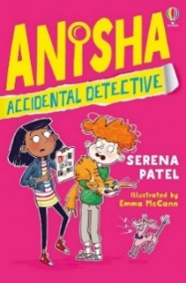 | Anisha, Accidental Detective by Serena Patel  HELP! My Aunty Bindi is getting married tomorrow but I've just found a ransom note saying Bindi's husband-to-be, has been kidnapped, and will only be freed if the wedding is cancelled! I guess it's up to me to save the day.  Interest age: 7-11  Reading age: 8+
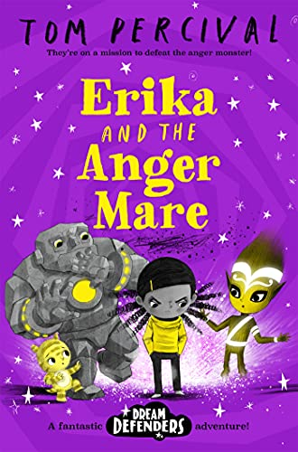 | Erika and the Anger Mare by Tom Percival  Erika Delgano can sometimes get a little angry…And one night things go from bad to worse when she falls asleep upset, she finds herself stuck in a bad dream with no way to get home, being chased by a terrifying Anger Mare!  Reading age: 7+  Interest age: 6-8
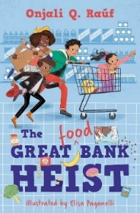 | The Great (Food) Bank Heist by Onjali Q Rauf  On Thursdays, Nelson, Ashley and Mum head out to the bank. But not just any old bank, the food bank. But there’s a thief in town, leaving people hungrier than ever. Can Nelson and his friends catch the bank robber?  Reading age: 7+  Interest age: 6-11
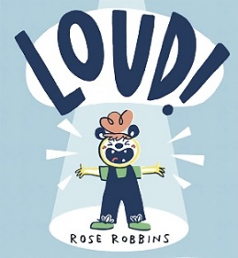 | Loud! by Rose Robbins  Abigail has ADHD and can’t concentrate, but one teacher knows just how to get her engaged, and Abigail ends up finding a special voice of her very own.  Interest age: 4-8  Reading age: 5+
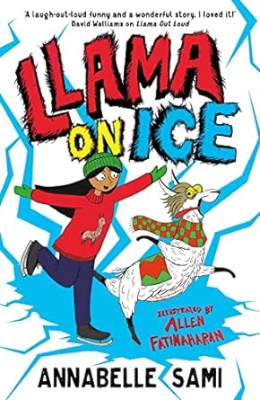 | Llama on Ice by Annabelle Sami  It's the Christmas holidays and Yasmin is miserable. Her family don't celebrate Christmas, so she doesn't understand all the hype. Laugh-out-loud funny and a wonderful story about finding your voice.  Reading age: 8+  Interest age: 8-11
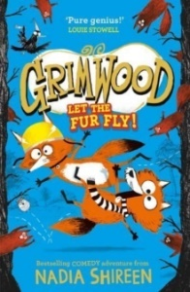 | Grimwood by Nadia Shireen  Fox cub siblings Ted and Nancy, are on the run from Princess Buttons. They flee for Grimwood, expecting to find refuge in the peaceful countryside. Instead, they are met with a whole host of unusual characters.  Interest age: 6-9  Reading age: 7+
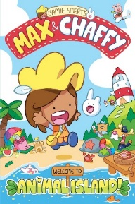
Max and Chaffy: Welcome to Animal Island by Jamie Smart
Max has just moved to Animal Island and it's full of new friends and a creature called a CHAFFY…but Chaffy is lost! Max must find where Chaffy belongs…and YOU can help!
Reading age: 5+
Interest age: 6-8
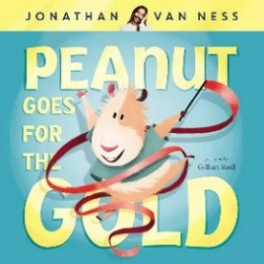 | Peanut Goes For The Gold by Jonathan Van Ness  Peanut Goes for the Gold is a charming, funny and heartfelt picture book that follows the adventures of Peanut, a gender nonbinary guinea pig, who does everything with their own personal flare.  Interest age: 4-8  Reading age: 5+
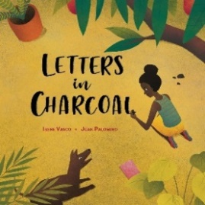 | Letters in Charcoal by Irene Vasco  In the pueblo of Palenque in Colombia, hardly anybody knows how to read. But with the help of the owner of the village shop, one young girl will slowly unlock the letters of the alphabet and discover the magic of reading.  Interest age: 6-8  Reading age: 6+
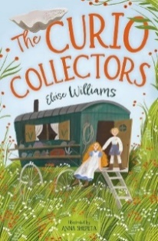 | The Curio Collectors by Eloise Williams  Lily and Tom travel the county, enthralling crowds with their amazing collection of curios. One day, Lily finds a special piece of scrimshaw. Can the Curio Collectors help the truth come to light?  Reading age: 8+  Interest age: 7-11
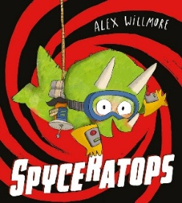 | Spyceratops by Alex Willmore  Meet the little dinosaur who is the GREATEST SECRET AGENT IN THE WORLD. Grandad is acting very suspiciously. Can he be trusted? BIG FAT NO. Spyceratops is on the case, determined to uncover Grandad’s secret…  Interest age: 6-8  Reading age: 5+
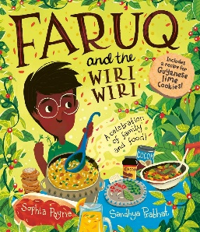 | Faruq and the Wiri Wiri by Sophia Payne  Faruq loves his grandmother Ajee, and he loves her cooking. In fact, Faruq would like to cook too - he wants to be a chef, but Ajee says he has to be a doctor like his father. Can his love of cooking change her mind?  Reading age: 7+  Interest age: 6+
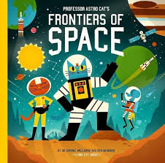 | Professor Astro Cat’s Frontiers of Space  Join Professor Astro Cat and the gang as they travel across space to find out everything there is to know about our galaxy, the solar system and the Universe. From asteroids to alien life and rockets to rovers, there’s so much to discover in the Frontiers of Space.  Interest age: 7-11  Reading age: 7+
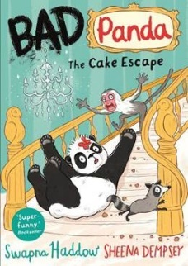 | Bad Panda: The Cake Escape by Swapna Haddow  Lin the panda is on a mission: to find her best friend, Fu. He's disappeared from the zoo! Has he been stolen by the Horrid Human? Only her badness can help her find him . . .  Reading age: 6+  Interest age: 6-9
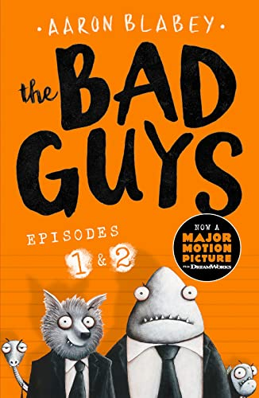 | The Bad Guys by Aaron Blabey  They sound like the Bad Guys, they look like the Bad Guys... and they even smell like the Bad Guys. But Mr Wolf, Mr Piranha, Mr Snake and Mr Shark are about to change all of that — whether you want them to or not!  Interest age: 6-9  Reading age: 6+
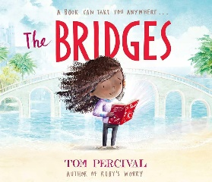 | The Bridges by Tom Percival  Mia feels alone; so alone that it's as if she lives on a small island, far out to sea. But then one day, Mia is given a book - the first she has ever been able to call her own. As Mia reads the book, bridges appear and her island fills with colour and life. And the more Mia reads, the stronger the bridges become, opening up a world of connection and hope...  Interest age: 5-8  Reading age: 6+
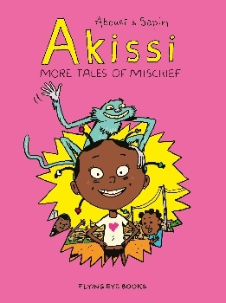 | Akissi: More Tales of Mischief  The plucky, troublemaking Akissi is back with her mischief on The Ivory Coast! This time, she has to keep herself from drowning, stand up to a bully, make peace with her arch-nemesis–the prettiest girl in school, and evade a witch doctor’s potion.  Interest age: 6-8  Reading age: 7+
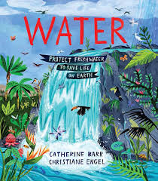 | Water: Protecting Freshwater to Save Life on Earth by Catherine Barr  A ground-breaking global introduction to water, that includes actions note on sharing and protecting freshwater worldwide. Water tells the story of freshwater around the world: discover the history of water, how the water cycle works, learn about the different kinds of water and about the amazing variety of wildlife that freshwater is home to.  Interest age: 6-11  Reading age: 7+
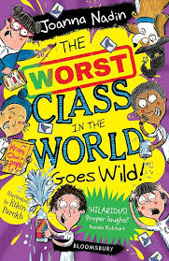 | The Worst Class in the World Goes Wild! By Joanna Nadin  A laugh-out-loud young fiction series from bestselling author Joanna Nadin, perfect for fans of Horrid Henry. Highly illustrated and featuring two hilarious madcap adventures in one book, these stories are just right for children ready for their first chapter books.  Interest age: 6-11  Reading age: 7+
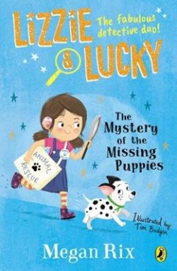 | Lizzie and Lucky: The Mystery of the Missing Puppies by Megan Rix  Lizzie is desperate for a dog. In order to convince her parents to get one, she has to come up with 101 reasons why she needs one. Lizzie is a master at making lists, so thinking of 101 reasons is going to be easy! Especially as she is deaf and could train one to be her hearing dog. The author’s experience of partial deafness informs this early chapter book, and provides helpful remindera about the importance of accessibility and equality.  Interest age: 6-8  Reading age: 6+

