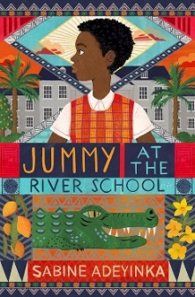 | Jummy at the River School by Sabine Adeyinka  Jummy has won a place at the River School, the finest girls' boarding school in Nigeria. Nothing can dampen her spirits. But when her best friend Caro suddenly arrives at the school to work, not to learn, Jummy must bring all her friends together to help.  Reading age: 8+  Interest age: 9-12
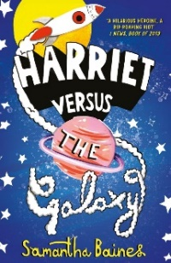 | Harriet versus the Galaxy by Samantha Baines  The intergalactic adventure starts at home with Harriet, who discovers that her hearing-aid can do more than she ever bargained for, when she finds an alien in her room.  Reading age: 7+  Interest age: 6-11
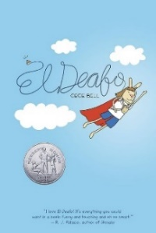 | El Deafo by Cece Bell  El Deafo is a funny, deeply honest graphic novel memoir for year 4 readers. It chronicles the author's hearing loss at a young age; and her subsequent experiences with a powerful and awkward hearing aid called the Phonic Ear.  Interest age: 8+  Reading age: 8+
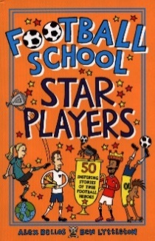 | Football School Star Players by Alex Bellos and Ben Lyttleton  What made Pele the greatest player of all time? How did Harry Kane overcome the odds to win the Golden Boot? And why is Megan Rapinoe so fearless in her beliefs? This collection of fifty biographies, tells the incredible true stories of footballs greatest legends.  Reading age: 9+  Interest age: 9-11
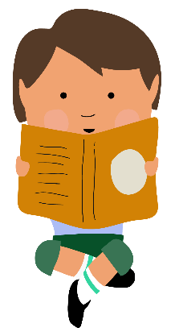

Recommended books for Year 4

Giving children a wide variety of exciting and engaging new books to choose from is vital to their development as a reader and forms a key part of our Young Readers Programme. Here, we’ve put together a list of books for ages 8-9 that is sure to appeal to a broad range of interests!
Click here to find all these titles on Browns Books

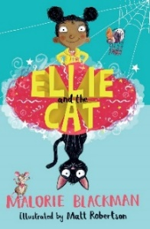 | Ellie and the Cat by Malorie Blackman  Ellie is the rudest, most spoilt child her grandma has ever met; and it's time that she learnt a lesson! So with a little bit of magic and some help from Jolly the cat, Grandma's going to make sure that Ellie changes her ways.  Interest age: 6-11  Reading age: 6+
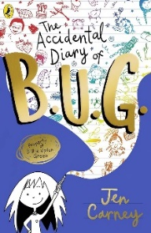 | The Accidental Diary of B.U.G. by Jen Carney  Meet Billie Upton Green and her VERY accidental diary. Billie has taken the new girl at school under her wing. She'll teach her the important stuff – and bring her to the EVENT OF THE YEAR (Billie's mums' are getting married).  Interest age: 8-10  Reading age: 8+  +
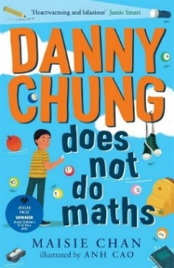 | Danny Chung Does Not Do Maths by Maisie Chan  Eleven-year-old Danny Chung loves drawing more than anything - certainly more than maths - which, according to his dad and everyone else, is what he is 'supposed' to be good at. Heart-warming, hilarious and filled with instantly loveable characters.  Interest age: 8-12  Reading age: 8+
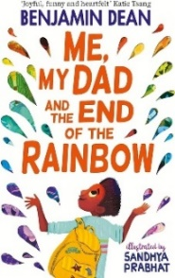 | Me, My Dad and the End of the Rainbow by Benjamin Dean  Things aren't going great for Archie Albright. His dad's acting weird, his mum too. When Archie sees a colourful, crumpled flyer fall out of Dad's pocket, he may have found the answer.  Reading age: 9+  Interest age: 9-11
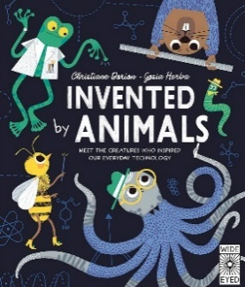 | Invented by Animals by Christiane Dorian and Gosia Herba  We have invented ways of solving problems, making materials and working out how to survive on our own for millions of years. Often human scientists try and solve a problem or invent a new tool that animals have already invented for them.  Reading age: 8+  Interest age: 8-11
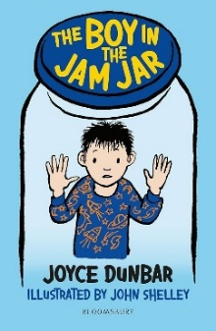
The Boy in the Jam Jar by Joyce Dunbar
Dylan can't hear as well as he used to be able to and he doesn't want to be different from his friends - he wants things to go back to the way they used to be. A heartwarming story, perfect for children who are developing as readers.
Interest age: 6-8
Reading age: 6+
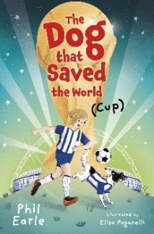 | The Dog that Saved the World (Cup) by Phil Earle  Pickles the dog and his owner Elsie love football more than anything. The World Cup is coming home to England and Elsie’s team have a chance to play in a half-time match at Wembley – with some help from Pickles, of course!  Interest age: 9-13  Reading age: 8+
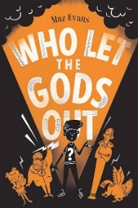 | Who Let the Gods Out by Maz Evans  When Elliot wishes upon a star, he doesn't expect a constellation to crash into a dung heap on his family farm. Are the Gods really ready to save the world? And is the world really ready for the Gods?  Interest age: 9-13  Reading age: 10+
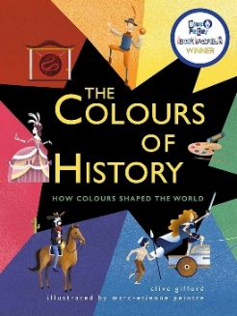 | The Colours of History by Clive Gifford  Why did Roman emperors wear purple? Which colour is made from crushed beetles? Find out the answers to these and many more questions, in this vibrant exploration of the stories behind different colours.  Reading age: 9+  Interest age: 9-11
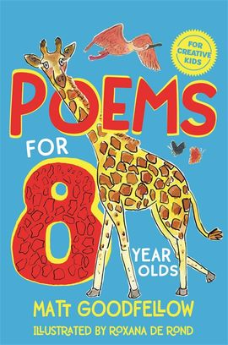 | Poems for 8 Year Olds by Matt Goodfellow  A brilliant collection of poems for 8-year-olds; packed with poems about friends, space, pets, nature, magic, family, school and adventure; compiled by Matt Goodfellow and illustrated by Roxana de Rond.  Reading age: 8+  Interest age: 8-10
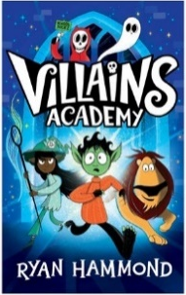 | Villains Academy by Ryan Hammond  It’s werewolf Bram’s first day at Villains Academy. He really doesn’t feel like a villain at all, but the coveted Villain of the Week trophy is up for grabs, and Bram knows he’ll have to dig deep.  Interest age: 6-8  Reading age: 7+
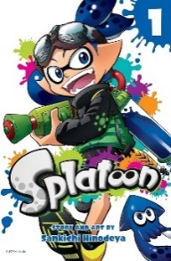 | Splatoon Vol.1 by Sankichi Hinodeya  Four Inklings, who can switch between human and squid forms, get caught up in a Splatoon Turf War that launches them into all-new adventures, based on the hit Nintendo video game series!  Interest age: 8-11  Reading age: 8+
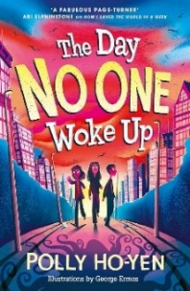  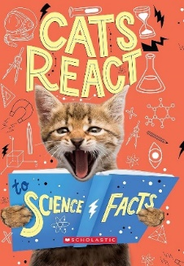 | Cats React to Science Facts by Izzi Howell  Share in the wonderment of science with a crew of crazy cats and measure your amazement, awe and disgust alongside their furry feline faces! Cats React to Science Facts is an engaging and fun way to understand the world of science.  Reading age: 7+  Interest age: 6-11
The Day No One Woke Up by Polly Ho-Yen
Something strange is happening in Ana’s city . . . she’s the only one awake. Confused and curious, Ana sets off to explore, bumping into the one other person who’s been able to rouse themself – her ex–best friend, Tio.
Interest age: 9-11
Reading age: 9+

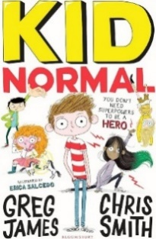 | Kid Normal Series by Greg James and Chris Smith  Murph Cooper has a problem. His new school is top secret, and super weird. His classmates can all fly or control the weather or conjure tiny horses from thin air. And what's Murph's extraordinary skill? Oh yeah, he hasn't got one.  Reading age: 9+  Interest age: 9+
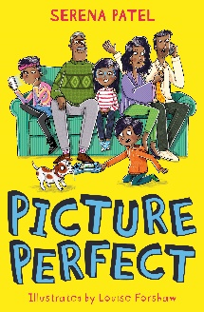 | Picture Perfect by Serena Patel  Sonal needs to capture a great family picture for her school photography project but it’s impossible when everyone’s always so busy! Luckily, they’re off on a family camping trip. Will Sonal’s family come together and have fun, or will the trip end in disaster?  Reading age: 6-8  Interest age: 9-11
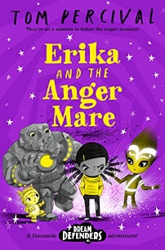 | Erika and the Anger Mare by Tom Percival  Erika Delgano can sometimes get a little angry…And one night things go from bad to worse when she falls asleep upset, she finds herself stuck in a bad dream with no way to get home, being chased by a terrifying Anger Mare!  Reading age: 7+  Interest age: 6-8
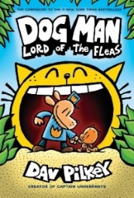  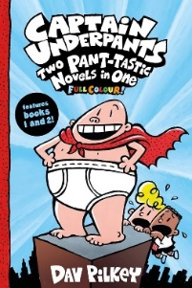 | Captain Underpants: Two Pant-tastic Novels in One by Dav Pilkey  George and Harold have created the greatest superhero in the history of their school — and now they're about to bring him to life!  Interest age: 7-12  Reading age: 7+
Dog Man: Lord of the Fleas by Dav Pilkey
When a new bunch of baddies bust up the town, Dog Man is called into action – and this time, he isn’t alone.
Reading age: 7+
Interest age: 6-8
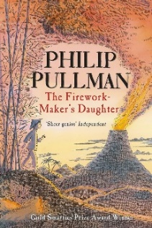 | The Firework Maker’s Daughter by Philip Pullman  What Lila wants to be, more than anything else in the world, is a Firework-Maker! But firework-making is not just about being able to make Crackle-Dragons and Golden Sneezes.  Reading age: 7+  Interest age: 7+
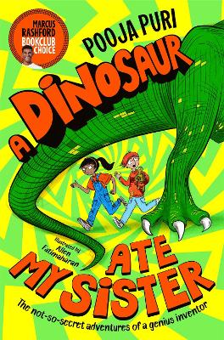 | A Dinosaur Ate My Sister by Pooja Puri  Esha Verma, her snotty apprentice Broccoli and his cunning pet tortoise, have a dream. They are going to win the legendary Brain Trophy – the ultimate inventing prize. This year's entry: A TIME MACHINE.  Reading age: 8+  Interest age: 9-11
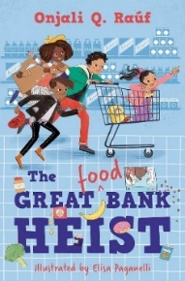 | The Great (Food) Bank Heist by Onjali Q Rauf  On Thursdays, Nelson, Ashley and Mum head out to the bank. But not just any old bank, the food bank. But there’s a thief in town, leaving people hungrier than ever. Can Nelson and his friends catch the bank robber?  Interest age: 6-11  Reading age: 7+
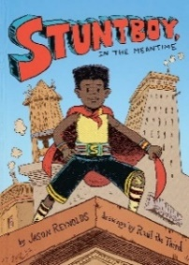 | Stuntboy: In the Meantime by Jason Reynolds  Portico Reeves's superpower is making sure all the other superheroes - like his parents and two best friends - stay super. And he does this all in secret. No one in his civilian life knows he's actually... Stuntboy!  Reading age: 9+  Interest age: 8-12
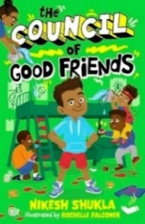 | The Council of Good Friends by Nikesh Shukla  Vinay, Musa, Inua and Nish are best friends. Nothing can separate them... until one day, when Vinay's cousin comes to invade his bunk bed haven. When a prank war starts, can the friends remember what really matters?  Interest age: 6-9  Reading age: 6+
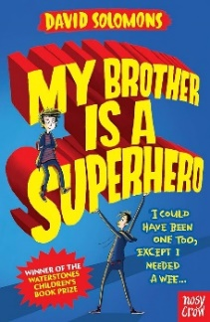 | My Brother is a Superhero by David Solomons  Luke, a comic-mad eleven-year old, shares a treehouse with his older brother, Zack. Luke' s only mistake is to go for a wee right at the wrong time. While he's gone, an alien gives his brother superpowers and then tells him to save the universe.  Interest age: 9+  Reading age: 9+
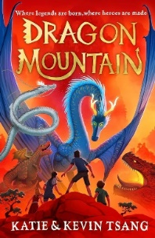 | Dragon Mountain by Katie and Kevin Tsang  When 12-year-old Billy Chan gets sent to a summer camp, he doesn’t know what to expect. There, he, and fellow campers stumble upon four powerful, warrior dragons, hidden deep within the mountain behind the camp.  Interest age: 9-11  Reading age: 9+
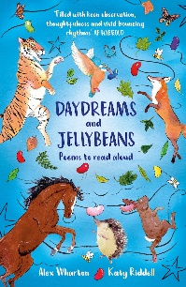 | Daydreams and Jellybeans by Alex Wharton and Katy Riddell  From forgotten jellybeans to sparking daydreams, Alex's poems, written for primary school age children, are both funny and thoughtful; and aim to spark familiarity and inclusion.  Reading age: 6+  Interest age: 6-8
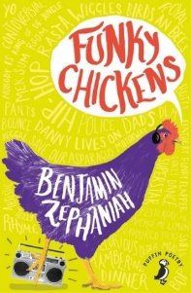 | Funky Chickens by Benjamin Zephaniah  Enter the crazy world of rap poet Benjamin Zephaniah! A reissue of the wonderfully irreverent collection of poetry for young people, touching on anything from vegetables, to the Queen and from sewage, to the sun.  Interest age: 9-11  Reading age: 9+
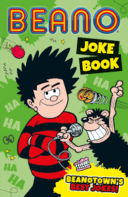 | Beano Joke Book by I.P Daley  It’s comedy night in Beanotown and Bash Street’s finest comedians have come together to compete for glory. Everyone has brought their funniest, most epic jokes with them to impress you. Who will you decide is the best joker?  Reading age: 7+  Interest age: 7-11
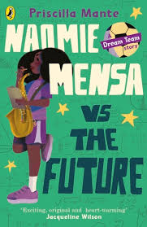 | Naomie Mensa vs the Future by Priscilla Mante  The third story in the heart-warming, inclusive and funny Dream Team series about three big F's: friends, football and following your dreams!  Interest age: 7-11  Reading age: 7+
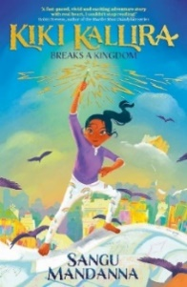 | Kiki Kallira Breaks a Kingdom by Sangu Mandanna  Kiki Kallira is more of a worrier than a warrior - but today she will learn to be a hero. The mythical beasts she loves to draw have come to life and she is the only one who can defeat them.  Interest age: 8-12  Reading age: 8+
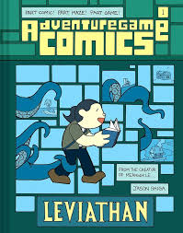 | Adventuregame Comics: Leviathan (Book 1): An Interactive Graphic Novel by Jason Shiga  Make choices to defeat a mysterious sea monster in the first of a new series of innovative, interactive graphic novels from the award-winning creator of Meanwhile Adventuregame Comics. Readers follow the story from panel to panel using tubes that connect them, and sometimes the path will split, giving readers the chance to choose how the story unfolds.  Interest age: 7-11  Reading age: 7+

